KanBird Automation Testing Report

What Tested:
I ran an automated test on the KanBird platform to check if I could successfully create new leads through the system. The test was designed to simulate a real user going through the complete lead creation process.

What Worked Well
- Login Process: The system successfully logged in using the provided credentials
- Navigation: Moving to the Leads section worked without issues
- Basic Form Fields: We were able to fill in basic information like title, expected revenue, contact details, organization, and product information

Major Problems I Found in KanBird Tool:
1.The "Plus" Button is Hard to Find:
The main button to create a new lead (the '+' button in the navigation) was very difficult for our automated test to locate. We had to try 8 different ways to find this button, which suggests the website's code doesn't have consistent identifiers for this important feature.

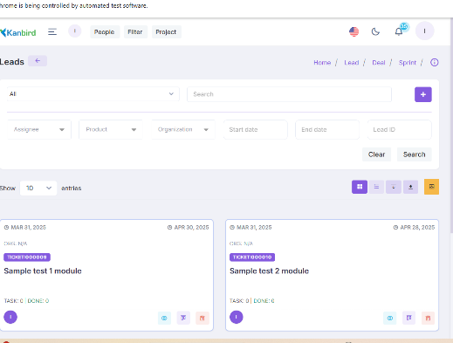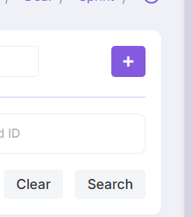

2. Date Selection Doesn't Work Properly:
When trying to select dates for "Start Date" and "Due Date":
- The calendar opens but we can't reliably select specific dates
- Multiple selection methods were attempted but none worked consistently
- This is a critical blocker since dates are required fields
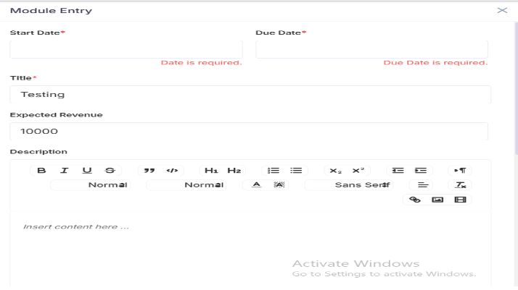

3. Dropdown Menus Are Unreliable:
The dropdown menus for "Assigned By" and "Assignee" fields failed completely:
- Could not find the "Intern" option in any of the dropdowns
- Tried multiple approaches to locate and select dropdown values
- All attempts to interact with these dropdowns failed

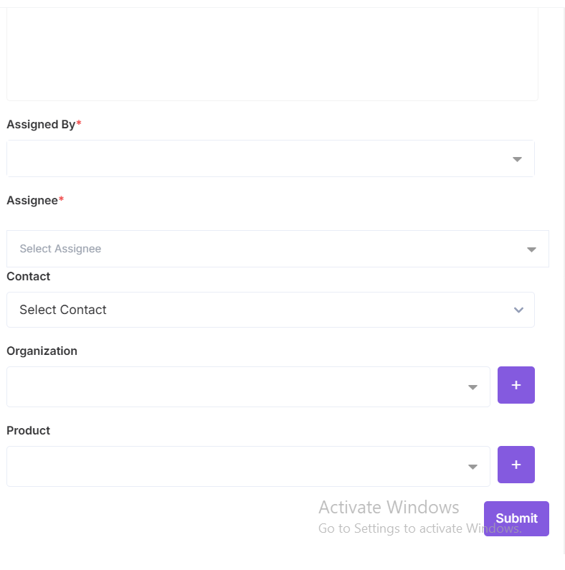

4. Form Submission Couldn't Be Tested
Because of the problems with date selection and dropdowns, we couldn't even reach the point of testing whether the form submits properly.
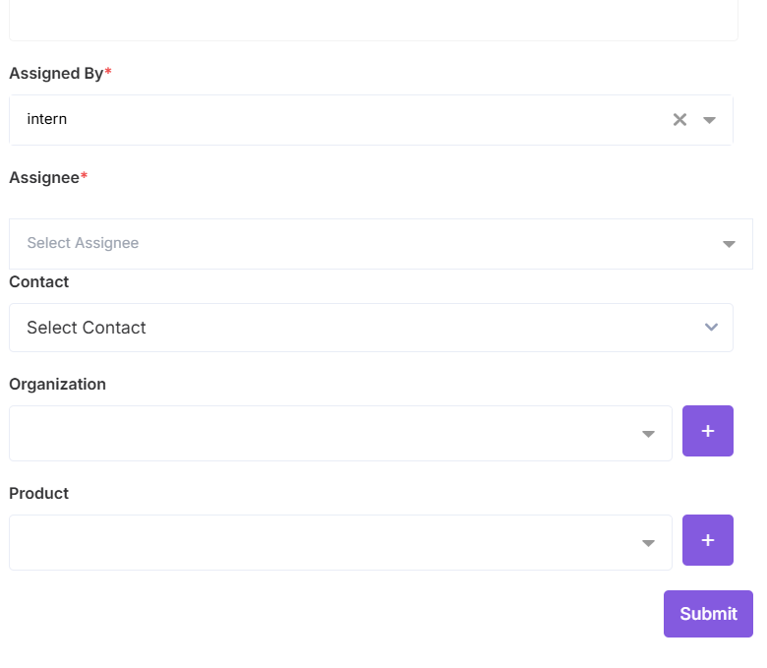
Why These Problems Matter

1.For Real Users:
If our automated tests are having these problems, real users might be experiencing similar issues:
- Difficulty finding the right buttons
- Frustration with date pickers not working
- Confusion when dropdown menus don't behave as expected

2.For Business Operations
- Sales teams might struggle to create new leads efficiently
- Data quality could suffer if users find workarounds that skip required fields
- Training new staff becomes more difficult when basic features don't work reliably

What Needs to Be Fixed:
High Priority Fixes:
1. Standardize Button Identification: Make sure all important buttons have clear, consistent identifiers in the code
2. Fix Date Selection: Ensure the calendar component works reliably for both manual and automated interactions
3. Repair Dropdown Menus: Make sure dropdown options are easily selectable and work consistently

Technical Improvements
- Add proper labels and identifiers to all form elements
- Ensure calendar dates are clickable and selectable
- Make dropdown options easily discoverable in the code

I recommend the development team addresses these issues in the following order:

1. Immediate: Fix the date selection and dropdown problems since they block lead creation entirely
2. Short-term: Improve button and form element identification for better reliability
3. Long-term: Establish standards to prevent similar issues in future features

Overall Assessment
While basic navigation and simple form fields work well, the critical functions needed to actually create leads are currently broken in the automated environment. Given that these are core business functions, we consider this a high-priority issue that needs immediate attention.

